Antibiotics
The term Antibiotic was introduced by S.A.Waksma in 1942. Antibiotics were natural drugs produced by several fungi or bacteria. They were different from chemotherapeutic drugs which were mainly produced by synthesis. The differences were abolished after chemical synthesis of some antibiotics was realized and development of new drugs from the natural products with binding various side chains to the basic structure.
The history of antibiotics begun in 1932 when the first sulfonamide was prepared. The boom of sulfonamides appeared thereafter with about 5.000 substances developed during years 1932- 1945. Sulfonamides were effective in urinary tract infections, shigellosis, pneumococcal pneumonia and even in purulent meningitis. But the effect of sulfonamides was totally exceeded with penicillin and streptomycin.
These two antibiotics (penicillin and streptomycin) covered the whole spectrum of bacteria. Penicillin was very effective against the most dangerous microbes of that time – pneumococci and streptococci and also against other important patogenes like staphylococci, meningococci, gonococci, Corynebacterium diphteriae, or Treponema pallidum. Streptomycin killed the gram- negative aerobic bacteria and Mycobacterium tuberculosis.
The effectiveness of penicillin and streptomycin against bacteria declined due to the rising of resistant species like mycoplasmata, chlamydiae staphylococci and rickettsiae. A solution to deal with these species was introduced in 1960. First semisynthetic antibiotics were prepared from the penicillin molecule – methicillin and ampicillin. These drugs were active against staphylococci and common gram-negative bacteria like E.coli, H.influenzae or S.enterica (including S.typhi abdominalis). Later on, many other semisynthetic antibiotics were made.
U.S. war in Vietnam in late sixties required better health care raised for injured, burn or shocked soldiers. It was the time of advancement and expansion of intensive care. The patients became able to survive the acute phase of trauma or shock but died for infectious complications. Most antibacterial agents were discovered during this period.
TWO MAIN GROUPS
- Bactericidal: Antibiotics that kill bacteria
- Bacteriostatic: Antibiotics that stop the growth of bacteria
What are antimicrobials?
Antimicrobials are drugs that destroy microbes, prevent their multiplication or growth, or prevent their pathogenic action. They differ in their physical, chemical, and pharmacological properties. They also differ in their antibacterial spectrum of activity and their mechanism of action. This lecture focuses on the different classes of antibiotics and their mechanisms of action.
Antibiotic classes and their mechanisms of action:
There are several major ways antibiotics kill microbes or inhibit their growth. Antibiotics generally target basic bacterial structures/functions necessary for life and/or replication.
Different mechanisms of action include:
1) Inhibition of cell wall synthesis
2) Inhibition of protein synthesis
3) Alteration nucleic acid metabolism
4) Inhibition of folate metabolism--necessary for production of DNA and other essential metabolites.
5) Miscellaneous mechanisms include disruption of the cell membrane and production of free radicals that damage DNA.
An ‘antibiotic class’ refers to a group of antibiotics with a very similar chemical structure. Because of their similar chemical structure members of an antibiotic class have the same basic mechanism of action. Generally, within a class, there is the same core nucleus critical to function, while differing side chains modify the drug’s toxicity, spectrum, pharmacokinetics, etc. For example, penicillins and quinolones are different antibiotic classes. Ampicillin and piperacillin are two different kinds of penicillins (both inhibit cell wall synthesis but have different antibiotic spectrums) while levofloxacin and ciprofloxacin are different kinds of quinolones (both alter nucleic acid metabolism, but are dosed once daily and twice daily, respectively). A few antibiotics classes are represented by only one antibiotic. One example is linezolid, which is the only oxazolidinone currently available.
Below, the different antibiotic classes are grouped by their mechanism of action:
Inhibit cell wall synthesis:
- Penicillins
- Cephalosporins
- Monobactams (aztreonam)
- Carbapenams
- Glycopeptides (vancomycin)
Inhibit Protein synthesis:
- Aminoglycosides
- Tetracyclines
- Glycylcycline (tigecycline)
- Macrolides
- Lincosamides (clindamycin)
- Streptogramins (quintapristin/dalfopristin)
- Oxazolidinones (linezolid)
- Phenicols (chloramphenicol)
Alter nucleic acid metabolism:
• Rifamycins (rifampin) • Quinolones
Inhibit folate metabolism:
• Trimethoprim • Sulfonamides
Miscellaneous:
• Metronidazole
- Lipopeptides (daptomycin)
- Polymixins
Figure demonstrating antibiotic targets:
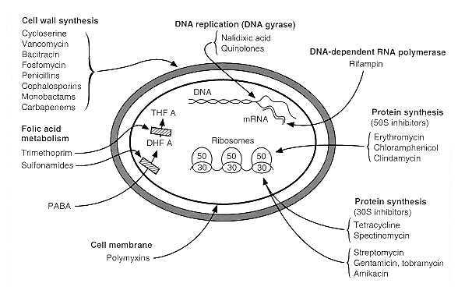
Antibiotics that inhibit cell wall synthesis:
Beta-lactam antibiotics all inhibit cell wall synthesis by
blocking the action of transpeptidases (aka penicillin binding proteins, PBPs) which are membrane bound and produce peptidoglycan, the major cell wall component. These antibiotics cause dividing bacteria to lyse and die as shown in the diagram below.
Some bacteria are able to produce a beta-lactamase which lyses the beta-lactam ring and disables the beta-lactam antibiotic. Beta-lactamase production is one mechanism of resistance that may be employed against these antibiotics. This is why some beta-lactam antibiotics are co-formulated with a beta-lactamase inhibitor. Examples are amoxacillin-clavulanate and piperacillin-tazobactam (beta-lactamase inhibitors are underlined).
Vancomycin (a glycopeptide antibiotic) Vancomycin also inhibits cell wall synthesis by
interfering with the production of peptidoglycan (but it is not a beta-lactam antibiotic). It does this by binding to the D-Ala-D-Ala
Beta-lactam antibiotics (penicillins, cephalosporins, monobactams, carbepenams): beta-lactam antibiotics refer to several classes of antibiotics (listed above) that all share the same beta-lactam ring consisting of 3 carbon atoms and 1 nitrogen atom. The beta-lactam ring is the square at the center of the penicillin nucleus shown to the right. The different classes of beta-lactams differ from each other by structures (such as side chains/rings) apart from the beta-lactam ring.
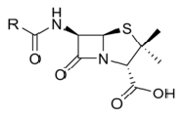
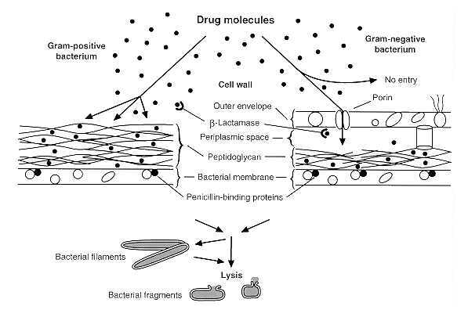
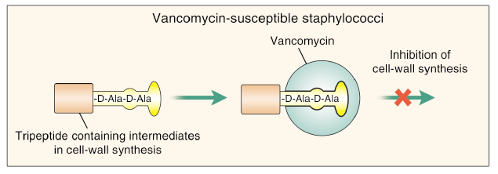
terminals of peptidoglycan precursors on the outer surface of the cell membrane. As a result, the precursors cannot incorporate into the peptidoglycan matrix. This process causes dividing cells to lyse and die. With a rare exception, vancomycin is only active against Gram positive bacteria. One mechanism of resistance against vancomycin is alteration of the bacterial D-Ala-D-Ala target.
Protein Synthesis Inhibitors
The protein synthesis inhibitors interfere with different aspects of translation. Some classes act on the 30S ribosome while others act on the 50S ribosome as demonstrated below. Most protein synthesis inhibitors cause a reversible inhibition of protein
synthesis and many are bacteriostatic (prevent bacterial growth but don’t kill them). An exception are aminoglycosides which bind irreversibly to the 30S ribosome and are generally bacteriocidal (cause cell death). (Note that an antibiotic’s bacteriostatic or bacteriocidal ‘status’ may not be set in stone—it may depend on the antibiotic’s
concentration and the organism). Aminoglycosides are also known for having a post-antibiotic effect where bacterial growth is inhibited for a time even after blood drug levels become undetectable.
Antibiotics that affect bacterial nucleic acid metabolism: Rifamycins
Rifamycins include several antibiotics including rifampin (aka rifampicin). They inhibit mRNA synthesis (transcription) by binding to the bacterial DNA- dependent RNA polymerase. Resistance may occur as a result of a single-step mutation (usually a missense mutation) within the gene that encodes the β- subunit of the RNA polymerase. Because resistance can easily occur, rifampin is almost always used in combination with other antibiotics. One exception is for N. meningitidis prophylaxis.
Quinolones
Quinolones inhibit DNA synthesis and cause cell death. They do this by inhibiting the topoisomerases responsible for supercoiling DNA (DNA gyrase) or relaxing the supercoiled DNA (topoisomerase IV). Ciprofloxacin is a quinolone that became a household name during the anthrax scare.
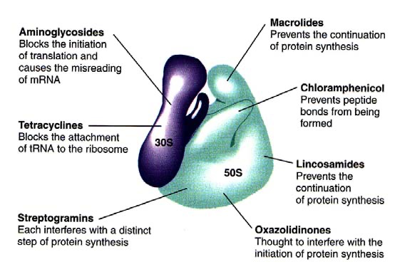
Quinolones: mechanism of action
Inhibitors of folate metabolism
Both trimethoprim and sulfonamides inhibit folate metabolism. When folate metabolism is inhibited, formation of DNA precursors (e.g. purines) is reduced and ultimately, DNA synthesis is inhibited.
Sulfonamides and trimethoprim act in
different steps in folate metabolism and are often used together. Sulfonamides inhibit tetrahydropteroic acid synthetase which inhibits PABAdihydrofolic acid. Trimethoprim inhibits the conversion of dihydrofolic acid to tetrahydrofolic acid by inhibiting dihydrofolate reductase.
Miscellaneous mechanisms of action
Metronidazole
Metronidazole is an antibiotic active against
anaerobes and select parasites such as entamoeba, trichomonas, and giardia. It diffuses into the cell and is reduced (in anaerobes, it is reduced by ferrodoxin, a mitochondrial electron transport protein). Metronidazole free radicals then cause breakage of organism DNA causing cell death.
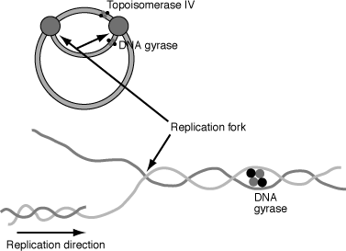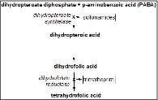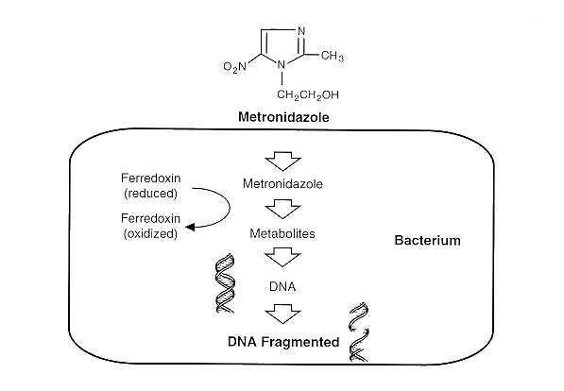
Lipopeptides (Daptomycin)
Daptomycin is the only antibiotic in the lipopeptide class. It binds to the cell membrane of Gram positive bacteria in a calcium-dependent process. Channels form causing ion leakage, depolarization of the cell, and cell death. Daptomycin is a useful agent for resistant staphylococcal and enterococcal infections; however, it can not be used for pulmonary infections as it is bound by surfactant.
Polymyxins
Polymyxins use a surface detergent-like mechanism to kill bacteria. They penetrate into cell membranes, interact with membrane phospholipids, and disrupt the membranes causing cell death. Polymixins are broad Gram negative agents. They are old drugs that became mainly restricted to topical and oral use (the oral formulation is not absorbed) due to toxicity. However, with the emergence of multi-drug resistant Gram negative bacteria, these drugs are being used intravenously with increasing frequency.
How are antibiotics used?
Antibiotics may be used as empiric therapy, definitive therapy, or prophylactic therapy. Empiric therapy is used when the pathogen has not yet been identified; therefore, an antibiotic must be chosen that is effective against the most likely pathogens. Antibiotics used for empiric therapy are usually broad spectrum, meaning that they are active against a wide variety of pathogens. For example, carbapenams are active against a wide range of Gram positive and Gram negative organisms. Definitive therapy is used once the pathogen has been identified (or the diagnosis is clear). When possible, a broad spectrum agent should be changed to a ‘narrower spectrum’ antibiotic once therapy becomes definitive. For example, a patient with pyelonephritis and shock may be treated empirically with piperacillin/tazobactam which is a broad spectrum antibiotic. If a pan-sensitive E. coli is identified in blood and urine cultures, the regimen could be changed to kefzol, which is a cephalosporin with a narrower spectrum. Finally, antibiotics may be used as prophylactic therapy with the aim of preventing an infection or its recurrence. For example, postal workers exposed to B. anthracis spores received a quinolone antibiotic to prevent anthrax from developing.
Will the antibiotic you choose be effective?
Before initiating antibiotics, you must decide whether or not the patient is infected. If you determine the patient is or may be infected and that antibiotic
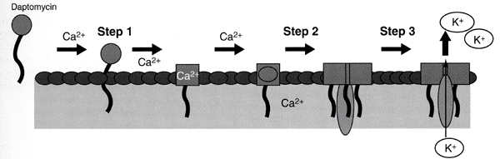
therapy should be initiated, cultures should usually first be obtained from the appropriate sites, if possible (e.g. aspiration of joint fluid for culture if septic arthritis is suspected or blood cultures if endocarditis is suspected).
The microbiology laboratory will identify the pathogen and determine its sensitivies in vitro to a panel of antibiotics. Sensitivity is determined by the interpretation of the minimum inhibitory concentration (MIC). The MIC is the lowest concentration of an antibiotic that prevents visable bacterial growth. ‘Susceptible’ means that the concentration of antibiotic in the serum is >MIC. ‘Resistant’ means that the organism will not be inhibited by acheivable drug concentrations in the blood. ‘Intermediate’ implies that if a high enough dose of the antibiotic is used, the antibiotic may be effective. The National Committee on Clinical Laboratory Standards (NCCLS) provides cutoff values that are both organism and antibiotic specific for help interpreting an MIC as meaning sensitive, intermediate, or resistant. A key issue is whether or not concentrations above the MIC can be achieved at the site of infection (e.g. lung, brain, etc.)--this must occur in order for the organism to be truly susceptible to antibiotic therapy.
Susceptibility can be determined in several ways, including broth dilution, E-test, and disk diffusion (these will be demonstrated in the Lab Sessions). In broth dilution, tubes with liquid media and increasing concentrations of antibiotic are innoculated with the organism. After 24 hours, the tubes are observed. The first tube (the tube with the lowest concentration of antibiotic) that has no visable growth represents the MIC.
In the figure on the left, the MIC=8 μg/ml. If the organism is Klebsiella pneumoniae and the antibiotic is cefepime (a cephalosporin), the organism would be considered susceptible to cefepime (the NCCLS guideline says that and MIC <8 μg/ml is
susceptible.) Though note that the MIC is one dilution away from being ‘intermediate’!
E-test (Epsilometer test): The e-test can
also determine the MIC. The e-strip
contains antibiotics in a gradient from a
low to high concentration. The organism
is innoculated onto a plate of solid media,
the e-strip is placed on the media, and
the plate is incubated for 24 hours.
Antibiotic on the e-strip will diffuse into
the solid media (also on a gradient). The
plate is observed and there will be an
elliptical-shaped inhibition of growth. The lowest point on the e-
strip the corresponds to an absence of growth equals the MIC. In this example, the MIC appears to be 4 mg/L (though it is difficult to read here).
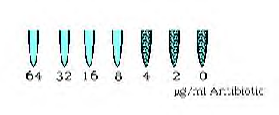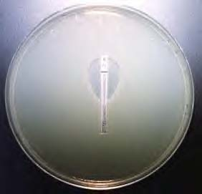 Zone of inhibition

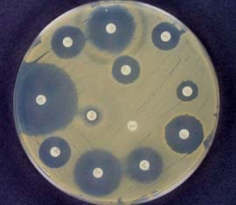
Bacterial lawn
This Kirby-bauer Disk Diffusion
Kirby- bauer Disk Diffusion: classic method of determining antibiotic susceptibility does not yield an MIC value—it just tells you if the organism is susceptible, intermediate, or resistant. In this method the organism is innoculated onto a plate of solid media. One or more antibiotic disks are placed onto the plate and the antibiotic will diffuse into the media. The plates are incubated for 24 hours and then observed. For each antibiotic disk, the zone of inhibition around it is measured. Depending on the diameter of the zone of inhibition, the organism will be classified as sensitive, intermediate, or resistant (NCCLS guidelines are used). Obviously, if there is no zone of inhibition, the organism is resistant to the antibiotic.
As stated above, in order for a pathogen to be sensitive to an antibiotic, the antibitotic concentration at the site of infection must be at or preferably above the MIC. Some antibiotics are concentration dependent agents--the higher the concentration of antibiotic above the MIC, the more killing occurs. Other antibiotics are time-dependent agents. For these agents, little is gained as the concentration increases above the MIC. For these agents, it is the duration of time that the concentration of antibiotic remains above the MIC that influences the extent of bacterial killing. These concepts are related to antibiotic pharmacodynamics (what the drug does to the body/bacteria) and must be weighed with the potential ill effects of antibiotics such as toxicity. For instance, aminoglycocides are concentration dependent agents— so the higher the concentration above the MIC, the better killing it achieves. However, aminoglycosides can also cause ototoxicity. Ototoxicity is related to the peak dose, but also to the total amount of drug exposure (area under the curve or ‘AUC’), which may be even more important. Therefore, one must carefully dose these antibiotics to achieve a favorable risk/benefit profile.
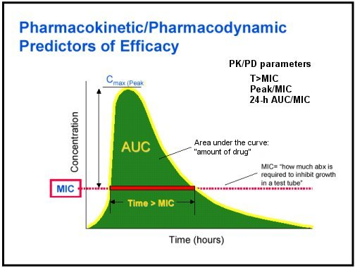
Some pharmacokinetic considerations are addressed below. (Pharmakokinetics are, essentially, what the body does to the drug.)
- 1) Absorption: if the agent is not administered IV, what % of the drug is absorbed? What other drugs, foods, or medical conditions might affect drug absorption? For instance, absorption of oral quinolones is diminished by the concomitant administration of antacids.
- 2) Volume of Distribution: this refers to the distribution of a drug throughout the body—a large distribution volume describes a drug widely distributed throughout the body while a small distribution volume refers to a drug with a more limited distribution (i.e. only in the bloodstream with little tissue penetration).
- 3) Metabolism: Drug metabolism, which mainly occurs in the liver, helps facilitate the removal of a drug from the body. Drug-drug reactions may interfere with drug metabolism. For instance, rifampin can increase the metabolism of other drugs such as protease inhibitors (use to treat HIV infection). Administration of these drugs together could result in ineffective treatment for HIV.
- 4) Excretion: Refers to elimination of a drug from the body which is either renal or non-renal. A patient’s ability to excrete an antibiotic must be considered (e.g. a person in renal failure would not be able to excrete a renally cleared antibiotic and could end up with toxic levels.)
Using Antibiotics in Combination:
The effect may be: 1) Synergistic 2) Antagonistic 3) Indifferent
Synergism is when the combination of two antibiotics is more lethal than the sum of the 2 antibiotics if given separately (it’s a super-additive effect). A classic example of antibiotic synergism is in the treatment of Enterococcal endocarditis where gentamicin (an aminoglycoside) is used in combination with ampicillin (a penicillin). Used alone, gentamicin (‘A’ in Panel 1 above) has very little effect because it can’t get inside the cell. Ampicillin (‘B’) does have a bactericidal effect. However, when used in combination, gentamicin can get inside the cell and bacterial killing is enhanced.
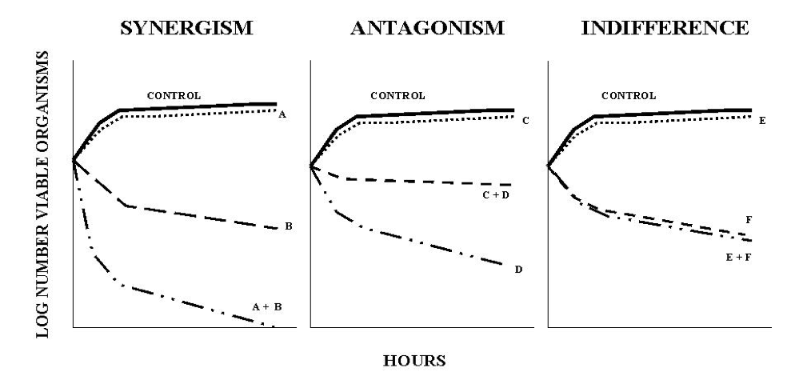
Antibiotic resistance will be addressed in more detail later in the course. However, there are four major mechanisms of antibiotic resistance to keep in mind:
1) Alteration of target
2) Prevention of access to target
3) Inactivation of agent
4) Failure to convert an inactive precursor agent to its active form
All drugs, including antibiotics, have pharmacodynamic and pharmacokinetic properties. Essentially, pharmacodynamics is what the drug does to the body/organism and pharmacokinetics is what the body does to the drug. These must both be considered when prescribing an antibiotic.

CLASSES OF ANTIBIOTICS
β-Lactam antibiotics
Examples: penicillins (e.g. amoxicillin), cephalosporins, carbapenems, monobactams, etc.
Brief history of Antibiotics
They are bactericidal drugs. They inhibit building of bacterial cell wall by interference with the synthesis of peptidoglycan. The effect of beta-lactams is mostly expressed against multiplying bacteria that are building their cell wall intensively. They are not effective against microbes without the peptodoglycan-containing cell wall (chlamydiae, mycoplasmata, rickettsiae, mycobacteria).
Pharmacokinetics: Many beta-lactams are acid-labile and decompose with gastric juice. In addition, absorption of beta-lactams from the gastrointestinal tract is limited. For these reasons, majority of beta-lactams has been prepared only in parenteral form. Esterified beta lactams are administered with food orally. Beta-lactams are spread mostly in the extracellular space. The penetration across biological barriers is limited, sometimes it can be reversed with higher dosing. Intracellular penetration of beta-lactams is poor. The vast majority of beta-lactams are excreted through the kidneys but exceptions do exist (oxacillin, cefoperazone, ceftriaxone).
They have short half life ranging from an hour (penicillin, oxacillin, cephalotin) to 2-2,5 hours. An exceptional long half time has ceftriaxone (8 hrs) allowing once daily administration.
Pharmacodynamics: It depends on the time above MIC (minimum inhibitory concentration). The target of dosing is to keep the level of antibiotic above MIC at the site of infection as long as possible. The peak concentration is not very important. In mild infections, the level of drug is sufficient that exceed MIC for 40-50% of the dosage interval.
circulation collapse......death e.g penicillin.
Undesirable effects: No serous side effects but can cause allergic reactions which leads to
Details of drugs in this group
1. Penicillins
The group can be divided in four subgroups:
They have narrow spectrum containing gram-positive and –negative cocci (streptococci, pneumococci, enterococci, meningococci), gram-positive bands (corynebacteria, L.monocytogenes), spirochetes (Leptospira sp., Treponema sp., Borrelia sp.), and most of anaerobes (peptostreptococci, clostridial species, Actinomyces).
A. Natural penicillins
• penicillin G or benzylpenicillin (unstable in gastric acid juice, suitable only for intravenous administration)
• penicillin V or phenoxymetylpenicillin (acid-stable form, for oral administration) procain- penicillin (depot form, for intramuscular administration, usually once daily)
• benzatinpenicillin (depot form, creating stabile low level of antibiotic for 2-4 weeks, useful for prophylaxis of streptococcal reinfections)
B. Anti-staphylococcalpenicillins
They are resistant to staphylococcal beta-lactamase but not to other beta-lactamases produced by gram-negative microbes. Examples: methicillin (only parenteral forms), nafcillin, oxacillin, cloxacillin, dicloxacillin. Oxacillin is the only drug registered in the Czech Republic. The daily dosage of oxacillin is 2g - 12g.
Remember: Methicillin-resistant strins of Staphylococcus aureus (MRSA) or Staphylococcus epidermidis (MRSE) have changed their PBP receptor and therefore are resistant to all beta-lactam
antibiotics. These microbes used to be simultaneously resistant to macrolides and lincosamides. Drug of choice in this situation is vancomycin.
C. Aminopenicillins
ampicillin (the basic representative of the subgroup, suitable for parenteral administration) amoxicillin (better adsorption after oral administration than ampicillin: 70-80% vs. 40-50%).
The drugs owe spectrum similar to natural penicillin with extension against common gram- negative bacteria like Escherichia coli, Salmonella enterica, Shigella sp., Proteus mirabilis, Helicobacter pylori, or Haemophilus influenzae. They are more effective than natural penicillin against enterococci and listeriae. The daily dosage of ampicillin is 2g - 12g.
Aminopenicillins should not be prescribed for patients suffering from tonsillitis until infectious mononucleosis has been excluded. Patients with mononucleosis readily develop severe maculopapular exanthema even after a few tablets of aminopenicillin. This effect is caused by production of heterophile antibodies and should not be interpreted as true and lasting allergy.
In case of resistance strains: Two combinations are available, both for oral and parenteral administration:
ampicillin + sulbactam
amoxicillin + clavulanic acid
The combinations are effective against above-mentioned gram-negative microbes owing beta- lactamase, and against Staphylococcus aureus. On the other hand, these antibiotics are needless and should not be prescribed against streptococci, enterococci or other bacteria that do not produce beta-lactamase.
D. Penicillins effective against pseudomonads (and other problematic gram-negative pathogens owing natural resistance). karbenicillin, ticarcillin, azlocillin, mezlocillin, piperacillin (only for parenteral usage). Their use is similar to the basic drugs. Combination of these antibiotics and beta-lactamase inhibitors were made as well: ticarcillin + clavulanic acid, piperacillin + tazobactam
2. Cefalosporins
Divided into four subgroups called generations. The individual drugs are arranged into generations according their spectrum of antibacterial activity (including the susceptibility/resistance to beta-lactamases.
1st generation: Used predominantly against gram-positive cocci (streptococci and staphylococci). Also used in corynabacteria, meningococci, and some community-acquired stems of gram- negative rods like Escherichia coli or Proteus mirabilis. The drugs are active against anaerobes in the extent similar to penicillin. Examples cefalotin - CLT, cefazolin – CZL (for parenteral administration), cefalexin - CLX, cefadroxil - CDR, cefaclor – CCL (for oral administration)
2 generation: Contain antibacterial activities of the 1 generation and extend to further community-acquired gram-negative bacteria like Haemophilus influenzae, Moraxella catarrhalis, or less susceptible strains of E.coli or similar patogens. Examples: cefuroxim - CRX, cefamandol – CMN (for parenteral administration) cefuroxim-axetil (for oral administration)
Prescribed for treatment respiratory tract infections (bacterial sinusitis or mesotitis, pneumonia), and urinary and hepatobiliary tract infections. They can be used for prophylaxis in surgery as well. Cefoxitin – CXT (only parenteral administration) .
3rd generation: Divided in two subgroups according to their activity against Ps.aeruginos Subgroup A: have enhanced activity against gram-negative bacteria (E.coli, H.influenzae, meningococci, salmonellae etc ) and weaker effect against staphylococci. Drugs: cefotaxim – CTX, ceftriaxon – CTR (for parenteral administration). cefetamet-pivoxil, cefpodoxim-proxetil, cefixim, ceftibuten (for oral administration)
Subgroup B included antibiotics effective against Ps. aeruginosa and other 􏰀problematic gram- negative pathogens. However, the stronger is the anti-pseudomonadal effect, the weaker is the activity against staphylococci and other gram-positive microbes. Ceftazidim – CTZ, cefoperazon – CPR (for parenteral administration)
4th generation: This group have a broad spectrum summarizing the 1st, 2nd and 3rd generation. Drugs include cefpirom, cefepim (only parenteral administration)
3. Carbapenems
Examples: imipenem, meropenem (only parenteral administration). These antibiotics are reserved for extreme resistant nosocomial infections/sepsis.
4. Monobactams
Examples: Aztreonam (only parenteral administration). Monocyclic beta-lactams are active against Enterobacteriaceae, Pseudomonas, and other gram-negative aerobic microorganisms. They resist many bacterial beta-lactamases.
GLYCOPEPTIDES
They are bactericidal drugs inhibiting bacterial cell wall synthesis in a step prior to beta-lactam action. They may also injure bacterial protoplasts or interfere with RNA synthesis. Pharmacokinetics: The drugs are not absorbed from the gastrointestinal tract. Penetration across biological barriers is poor. The drugs are excreted almost exclusively by glomerular filtration.
Pharmacodynamics: The effect of glycopeptides depends on the „time above M)C􏰀. They perform postantibiotic effect of about 2 hours.
Disposal: Reserve antibiotics for the treatment of serious gram-positive infections. They are used when beta-lactams can not be given because of allergy of the patient or because of resistance of the microbe.
Examples: Vancomycin, Its usage requires special caution: The drug must be administrated in a slow infusion 􏰄≥ 􏰂 hour􏰅 and serum concentration should be measured. The dosage must be balanced very carefully because of significant nephrotoxicity and ototoxicity of the drug. In the treatment period, renal function should be monitored thrice or twice a week.
Adverse effects of vancomycin involve fever, chills, exanthema, and phlebitis at the site of infusion. Reversible leukopenia, thrombocytopenia, or eosinophilia may develop as well. Flushing due to
histamin release 􏰄􏰀red man syndrome􏰁􏰅 and/or hypotension frequently occur after rapid
intravenous administration. Renal failure and hearing loss are the most fearing sequellae of treatment with vancomycin: nevertheless, they are not frequent when the above mentioned recommendations are kept.
Vancomycin can also be given orally when pathogenic bacteria are localized in intestinal lumen. The typical example is colitis caused by Clostridium difficile.
Teicoplanin: This antibiotic penetrates better in tissues except brain. It has a very long half-time (33-70 hours) and can accumulate in organism. The first three doses should be given in 12-hour period for saturation, then the drug can be given once daily or in every-other-day regime. Teicoplanin is well tolerated and can be administered in a rapid infusion, slow intravenous injection, or intramuscular injection. The adverse effects are much less frequent. The allergy and also resistance is only partially crossed between vancomycin and teicoplanin.
AMINOGLYCOSIDES
They have very strong and rapid bactericidal effect on bacteria. They act in several sites of bacterial cell (outer membrane, ribosomes). A very important feature of aminoglycosides is synergism with the wall-affecting antibiotics (beta-lactams, glycopeptides). This synergism is expressed against some gram-positive (streptococci, enterococci) as well as gram-negative (E.coli, Pseudomonas) bacteria.
Aminoglycosides are not effective against anaerobes, spirochetae (genus Leptospira, Borrelia, Treponema), obligatory intracellular pathogens (chlamydiae, rickettsiae, legionellae), and capsulated pathogens (pneumococci, Salmonella typhi, Haemophilus influenzae).
Account of drugs:
streptomycin
It is an old drug used in the treatment of tuberculosis. There are some more indications for the very special situations (severe infections caused by enterococci highly resistant to gentamicin). gentamicin, tobramycin, netilmicin
Gentamicin is a standard and most widely used aminoglycoside in the Czech Republic. Tobramycin is somewhat more effective against Pseudomonas. Netilmicin is slightly less nefrotoxic. In practice, the difference between these antibiotics is not very significant.
amikacin, isepamicin
These antibiotics resist various bacterial destructive enzymes, so can be used against some more resistant stems of nosocomial gram-negative pathogens. They do not work stronger than gentamicin but are somewhat less nefrotoxic.
Pharmacokinetics of aminoglycosides is similar to that of vancomycin. They are not absorbed from the gastrointestinal tract. Penetration across biological barriers is poor. Volume of distribution correlates closely with the volume of extra-cellular fluid. The drugs are excreted unchanged by glomerular filtration.
Pharmacodynamics: The bactericidal effect is concentration-dependent. It relates to the peak concentration of the antibiotic at the site of infection. Postantibiotic effect (PAE) lasts several hours depending on the reached peak concentration.
The effectiveness of aminoglycosides is influenced with pH: It is optimal in mild alcalic pH and
losses activity rapidly with lowering pH under 6,5.
Undesirable effects: Allergic reactions are rare. Gastrointestinal disorders are uncommon because of pharmacokinetics passing the gastrointestinal tract. Local events (irritation, thrombophlebitis) are rare as well. Nevertheless, the drugs are nefrotoxic and ototoxic: They can
cause necrosis of the proximal tubular cells leading to reversible renal failure within several weeks or even days.
(FLUORO)QUINOLONES
They are bactericidal antibiotics but are not as potent as beta-lactams or aminoglycosides. They interfere with DNA metabolism in the bacterial cell. They are active mainly against gram-negative bacteria but the modern drugs are effective against gram-positive bacteria, intracellular pathogens, and even some anaerobes.
The group of older drugs consists of nalidix acid, pipemidic acid, and oxolinic acid. They are quinolones without fluorine substituent on their ring. They are only oral preparations.
The second group of drugs consists of fluoroquinolones owing systemic effect. They spread well in the most tissues and penetrate into cells. Their spectrum is wider than in the former group: gram- negative bacteria including Pseudomonas aeruginosa and other less susceptible microbes, staphylococci, chlamydiae, legionellae, and some mycobacteria. However, the are not effective against pneumococci, streptococci, spirochetae, and anaerobes. The most important representatives of this group are ciprofloxacin, ofloxacin, and pefloxacin. They differ especially in their route of elimination: Ofloxacin is excreted almost entirely by the kidney. Ciprofloxacin and pefloxacin are partly metabolized in the liver; and excreted via urine and feces.
Adverse events in quinolone antibiotics are heterogenous and differ in various drugs in both frequency and severity. They are gastrointestinal disorders, fotosensibilisation, allergy, leucopenia, thrombocytopenia, spasms, tendinitis, and even tendon ruptures. They affect pharmacokinetics of drugs metabolized in liver cytochrome P450 system.
NITROIMIDAZOLES
They are bactericidal narrow-spectrum antibiotics, effective against most anaerobes (except aktinomycetes, Propionibacterium acnes and anaerobic-growing streptococci) and some protozoa (Trichomonas vaginalis, Entamoeba histiolytica, and Giardia lamblia). The antibiotics interfere with electron transport in anaerobic metabolic pathways of bacterial or protozoal cells.
Pharmacokinetics: The drugs are very well absorbed from the gastrointestinal tract. After absorption, they posse excellent penetration across biological barriers including blood-brain and placental barrier. The drugs are metabolized in the liver by 40% and excreted mainly by the kidney.
Adverse events are usually mild and include gastrointestinal disorders (glossitis, metallic taste, dry mouth, nausea), allergy, headache, dizziness etc. Neurotoxicity was reported as a seldom reaction (seizures, encephalopathy, peripheral neuropathy, ataxia).
Disposal: Nitroimidazoles are used in
- moderate to severe anaerobic infections including life-threatening clostridial infections (gas
gangrene) and pseudomembranous colitis caused by Cl.difficile,
- mixed bacterial infections (in combination with other antibiotics),
- above mentioned protozoal infections.
metronidazol
It is the most widely used nitroimidazole because of persisting in prescription habits and low cost. ornidazole, tinidazole
They have more advantageous phamacokinetic parameters (a half-time of 13 hours allowing once- daily administration) and less frequency of adverse events.
Pharmacokinetics: The drug is well absorbed from the gastrointestinal tract: its serum levels after oral and intravenous administration are equivalent. Chloramphenicol penetrates excellently across biological barriers including the blood/brain and blood/liquor barrier. It enters the cell compartment as well.
CHLORAMPHENICOL
The antibiotic posse bacteriostatic or –cidal activity against a variety of microbes including gram- positive and gram-negative bacteria, anaerobes, spirochetes, and obligatory intracellular pathogens (chlamydiae, rickettsiae, mycoplasmata). Mechanism of action is inhibiting protein synthesis on the ribosomal level.
Chloramphenicol is metabolized in the liver and then excreted by the kidney.
Adverse events: The most important undesirable effect of chloramphenicol is its toxicity for bone marrow. It is manifested by anemia, leucocytopenia, thrombocytopenia, or any combination thereof. Two forms of toxicity are distinguished:
early toxicity occurring usually after 2 weeks of treatment. It is dose-dependent and reversible. Disposal: Because of the risk of aplastic anemia, chloramphenicol is used only as a reserve drug – despite its broad spectrum and advantageous pharmacokinetic parameters.
The acceptable indications are:
• brain abscess and purulent meningitis 􏰄because of excellent penetration􏰅
• severe infections/sepsis caused by mixed aerobic and anaerobic flora (peritonitis, septic
empyema caused by mixed flora)
• severe rickettsial infections 􏰄Q fever, Rocky Mountains spotted fever, typhus)
Former indications (typhoid fever, invasive Salmonella infections, pertussis, epiglotitis etc) are left
because cefalosporines of 2nd or 3rd generation or fluoroquinolones can be given instead. Chloramphenicol must not be prescribed for gravid women and it is not advisable for newborns and sucklings: the liver in very young organism can not metabolize chloramphenicol sufficiently and the drug cumulates in tissues constituting so-called gray baby syndrome.
LINCOSAMIDES
They are two static antibiotics reversibly inhibiting protein synthesis on ribosomal level in the same way as macrolides. However, they have narrow spectrum and are active only against gram- positive bacteria (mainly staphylococci and streptococci) and anaerobes. Clindamycine is also active against some protozoa. Resistance to lincosamides is completely crossed mutually, and partially crossed with macrolides.
Pharmacokinetics: Both antibiotics are absorbed form the gastrointestinal tract or can be given parenterally. They penetrate well in most tissues including bone but do not pass the blood-brain barrier. Like macrolides, they concentrate in phagocytic cells and achieve high levels in pus. They are partly metabolized in the liver and excreted in the bile and urine.
Undesirable effects: The antibiotics are not toxic. Allergic reactions or gastrointestinal intolerability can occur. The most important adverse reaction in antibiotic-associated pseudomembranous colitis caused by Clostridium difficile. These reaction can occur in association with administration of other antibiotics (aminopenicillins, some cephalosporines) as well.
thrombophlebitis in abdominal area, severe forms of pelvic inflammatory disease, chest
Disposal: The antibiotics suit better to subacute infections than to acute infections or sepsis (static effect, good penetration). Their usage is more appropriate in community-acquired than in nosocomial infections. Methicillin-resistant staphylococci (MRSA, MRSE) are readily resistant to lincosamides.
Lincosamides are used especially in mixed staphylococcal/streptococcal infections or in infections caused by mixed aerobic/anaerobic flora. Main indications are skin and soft tissue infections, diabetic foot, odontogenic infections, tonsillitis and peritonsillar abscess, and aspiratory pneumonia. Clindamycin in combination with anti-parasitic drugs is prescribed for treatment malaria, toxoplasmosis, or amebiasis.
lincomycin
It is somewhat weaker than clindamycin and was replaced with clindamycin in majority of indications. Its only advantage is a possibility of enhancing the dosage up to 10-15 g daily. It may be important in some situations where penetrance into the site of infection is problematic. However, these high doses must be given in slow infusions because of risk of hypotension. clindamycin
The antibiotic works stronger and is better absorbed when administered orally. The drug is prepared in a form of phosphate and must be decomposed in organism with enzymes (phosphatases) to make an active antibiotic. Because of saturability of these enzymes, the total daily doses of clindamycine should not exceed 4,8 g.
TETRACYCLINES
They are static antibiotics reversibly inhibiting protein synthesis. They block bacterial ribosomes in other site than do macrolides and lincosamides. Originally, their antimicrobial spectrum was broad including many gram-positive and –negative bacteria, and anaerobes. Unfortunatelly, many pathogens have developed resistance. At present time, tetracyclines are preferentially used in treatment of various infections caused by non-pyogenic bacteria. Resistance within tetracycline family is completely crossed. caused by non-pyogenic bacteria. Resistance within tetracycline family is completely crossed.
Pharmacokinetics: Tetracyclines are well absorbed from the gastrointestinal tract. They penetrate excellently into various tissues and into cells. They are excreted into mucosal fluid, breast milk, bile and urine in clinically significant concentrations (see below). Nevertheless the drugs excreted into bile is reabsorbed in the gut (enterohepatic circulation).
Adverse events: Gastrointestinal and neurovegetative disorders of variable intensity are relatively frequent. Oral, intestinal, vaginal and skin dysmicrobia is common as well: candidial superinfection is a frequent consequence. Mild to moderate liver or renal damage can occur. Photosensitivity reactions can be seen in patients who stay in the sun shine. In children, permanent teeth discoloration develops related to the total amount of absorbed tetracycline. Tetracyclines must not be prescribed for gravid and breast feeding women and for children until 8
years.
Many interactions were reported at concomitant treatment with tetracyclines and various other drugs.
Disposal: There are several indications which tetracyclines are used in:
1) Respiratory, genitourinary or occular infections caused by chlamydiae, mycoplasmata, and
ureaplasmata. These infections include 􏰀atypical pneumonia􏰁, acute and chronic urethritis
and/or urethral syndrome, epididymitis, cervicitis, some of pelvic inflammatory diseases, inclusion conjuctivitis and trachoma. (Alternative drugs are macrolides.)
2) Rickettsial infections: Q fever, ehrlichiosis, typhus fever etc. (Alternative drug is chloramphenicol.)
3) Spirochetal infections: Lyme borreliosis, relapsing fever (Borrelia recurrentis), leptospirosis, syphilis and other treponemal infections. (Alternative drugs are penicillins, cephalosporines, macrolodes.)
4) Some other anthropozoonoses caused by non-pyogenic bacteria: brucellosis, campylobacteriosis, malleus, pasteurellosis, plague, rat-bite fever, or tularemia. (Alternative drugs are fluoroquinolones.)
5) Mild to moderate infections caused by anaerobes: acne, actinomycosis, some pelvic inflammatory diseases. (Alternative drugs are lincosamides and other antibiotics effective against anaerobes.)
Remember: In majority of above-mentioned pathogens, no systematic monitoring of resistance exists due to problems with cultivation. The percentage of resistance (and probability of successful treatment with various antibiotics) is not known.
tetracycline, oxytetracycline
These drugs are rather of historical importance. They are replaced with new tetracyclines:
doxycycline, minocycline
These tetracyclines are better absorbed from gatrointestinal tract and have longer half-time (about 17 hours) allowing once-daily administration. They have substantially lower frequency of adverse events. Doxycycline is excreted via intestinal secretion, too, allowing treatment even in renal insufficiency
MACROLIDES and relative drugs
They are static antibiotics reversibly inhibiting protein synthesis on ribosomal level. In some microorganisms, the effect of macrolides can be cidal in appropriate circumstances. The structure is derived from a 14- to 16-member macrocyclic lactone ring, therefore the class name 􏰀macrolide􏰁.
Macrolides undergone an impressive evolution: Originally, they exhibited a broad-spectrum antibacterial activity involving gram-positive and gram-negative bacteria, anaerobes, spirochetes, and obligatory intracellular pathogens (chlamydiae, mycoplasmata). The most important drug of that time was erythromycin
Pharmacokinetics: The drugs are fairly absorbed from the gastrointestinal tract. They penetrate into most tissues and host cells excellently. The concentrations in phagocytic cells exceed peak maximum serum levels by severalfold. On the other hand, macrolides penetrates poorly into brain, synovial fluid and fetal tissues.
The drugs are excreted into mucosal fluid, breast milk, bile and urine. The ratio of urinary/fecal excretion is variable. The portion of drug excreted into bile is partially reabsorbed in the gut (enterohepatic circulation). Some drug is metabolized in the liver as well.
Adverse reactions: Macrolides are very safe and non-toxic antibiotics. Nevertheless, gastrointestinal disorders may occur, especially with 14-chain macrolides like erythromycin (see below). Allergic reactions (rash, fever or eosinophilia) are infrequent. Liver damage can occur after esterified erythromycin, especially in pregnancy.
Various interactions have been reported between macrolide and other drugs. They are based on inactivating the cytochrome P-450 hepatic enzyme system or on changes in bioavailability due to affecting gut flora.
Generally, macrolides can be prescribed for gravid woman. Claritromycin was reported to interfere with angiogenesis and produce teratogenic effect in animals when high dosed but it is approved with caution for gravid woman.
Disposal: Macrolides are used in respiratory infections, mainly in 􏰀atypical pneumonia􏰁 and in legionellosis. The other indication is urogenital infections caused by chlamydiae, mycoplasmata, and ureaplasmata. Macrolides may be used for treatment tonsillitis or lyme borreliosis (erythema migrans) in patients with allergy to beta-lactam antibiotics.
Special indications include campylobacteriosis, tularemia in children, mycobacteriosis (in association with other antibiotics)
Account of drugs: The family of macrolides is divided according to the number of members in their lactone ring. The 14-chain macrolides have stronger antibacterial effect but higher frequency of adverse reactions
erytromycin
The oldest macrolide. Its usage is associated with relatively frequent vomiting or reversible hepatic damage mainly in older preparations.
roxitromycin, claritromycin
Modern macrolides. Roxithromycin works somewhat weaker than erythromycin, claritromycin is relatively strong. Clarithromycine ́s influence on angiogenesis was mentioned above.
Members of the 16-chain lactone subgroup work relatively weaker that the 14-chain macrolides but have minimum adverse events.
spiramycin, josamycin
They are especially suitable for infants and children or for long-time administration (therapy of toxoplasmosis in gravid women, long time prophylaxis of streptococcal infections in patients with allergy to beta-lactams).
Similar to macrolides are azalides. The representant of those drugs is azitromycin. This drug is somewhat more active against sensitive gram-negative microbes and has very special farmakokinetic parameters:
- very long half-time (2-4 days): a 3-day administration can make therapeutical levels in tissues for 7-14 days
- the drug is transported to a locus of inflammation in leukocytes. Consequently, drug concentration in the site of inflammation is high, whereas serum concentration is extremely low.
CO-TRIMOXAZOL
The drug consists of synergistic combination of two inhibitors of folic acid metabolism: sulfamethoxazole + trimethoprim. Both the sulfonamides and trimethoprim are static but the combination can have cidal effect against some bacteria.
Pharmacokinetics: Both sulfamethoxazole and trimethoprim are well absorbed from the gastrointestinal tract and penetrate excellently into tissues and cells. They penetrate across blood- brain barrier and placental barrier, too. The drugs are partly metabolized in the liver and excreted almost entirely through the kidney.
Adverse events are relatively frequent and include allergy (rash or fever but also erythema multiforme including Stevens-Johnson syndrome, vasculitis and anaphylaxis), gastrointestinal disorders (nausea, vomiting, diarrhea), headache, hematotoxicity (neutropenia, thrombocytopenia, anemia), nephrotoxicity and fototoxicity. Sulfonamides compete for bilirubin- binding sites on plasma albumin and may increase blood levels of unconjugated bilirubin. Therefore, co-trimoxazol can not be given to pregnant women or to newborns and sucklings up to the age of 2 months. Frequent drug interactions also were reported between co-trimoxazol and other drugs.
Disposal: severe diarrheal diseases with fever (especially if salmonella is expected to be the cause), urinary tract infections, respiratory infections where pneumococcal or H.influenzae etiology can be expected (lobar pneumonia, sinusitis, otitis media). However, co-trimoxazol is rather a drug of second choice for most of these infections because safer and/or more effective alternatives do exist.
Special indications include therapy or prophylaxis in HIV/AIDS patients (pneumocystosis, toxoplasmosis, isosporosis), nocardiosis, brucellosis, long-term treatment of staphylococcal osteomyelitis etc.
Monotherapy of trimethoprim is used for treatment urinary tract infections in regions with
isolated resistance to sulfonamides.
NITROFURANTOIN
Bacteriocidal drug, nevertheless effective concentrations are reached only in urine.
Spectrum: good effect against enterobacteria (E.coli, Klebsiella, Enterobacter, ..),
excellent effect against enterococci
Adverse events: frequent: allergy, gastrointestinal disorders, neuropathy, autoimunne pneumonitis. The drug must not be used in gravid women
Disposal: therapy and prophylaxis of urinary tract infections
Local administration: vaginal globulae, pastae for dermatological praxis)
MECHANISMS OF RESISTANCE
1) enzymatic destruction of ATB
easy to transfer and to spread
several genes bond in one plasmide
2) block of ATB penetration into cell (gram-negative bacteria) 3) efflux of ATB
4) change of the target molecule (MRSA, MRSE) difficult to develop

